# **2nd Story - Cyber Bazaar**

In the sprawling expanse of the *Cyber Bazaar*, where algorithms hum and virtual stalls buzz with the clamor of encoded exchanges, communication is more than a tool—it’s the essence of existence. As living organisms, communication is a fundamental activity of connecting individual entities in order to develop linkages and form groups. For human society, communication is considered an important component in the formation of communities, it is the glue that binds individuals together. The communication process is defined as the *transmission of information*. Communication activities are the act of developing meaning among entities or groups through the use of a sufficient number of mutually understood signs, symbols, and semiotic conventions.[1] The communication act always involves a specific medium to form and forward information. Initially, humans use their bodies as mediums to create and transmit information. We use limbs to make gestures, carriage, and eyes to receive those. The palate can make sounds; through sounds, oral language is formed and emitted, and then received by the ears.

Throughout the history of *Homo Sapiens*, we have witnessedthe *parallel shift* between remarkable social changes and significant transformations in the *communication medium*; in particular, we have seen how information content has been created and the means by which information is transmitted.[2] As an example, the introduction of written communication marked a new stage in social knowledge formation, historical documentations, and collective memory establishment. Knowledge and history have been condensed into recorded characters and commonly used by governors. From hand writing to woodblock printing, books have been an integral part of religious and administrative apparatuses for thousands of years. That is why the oldest known printed book is the *Diamond Sutra* - an important *Mahayana Buddhist* text from the Chinese.[3] Or, the first book in the world to adopt mass printing techniques with moveable types is the *Christian Bible*.[4]

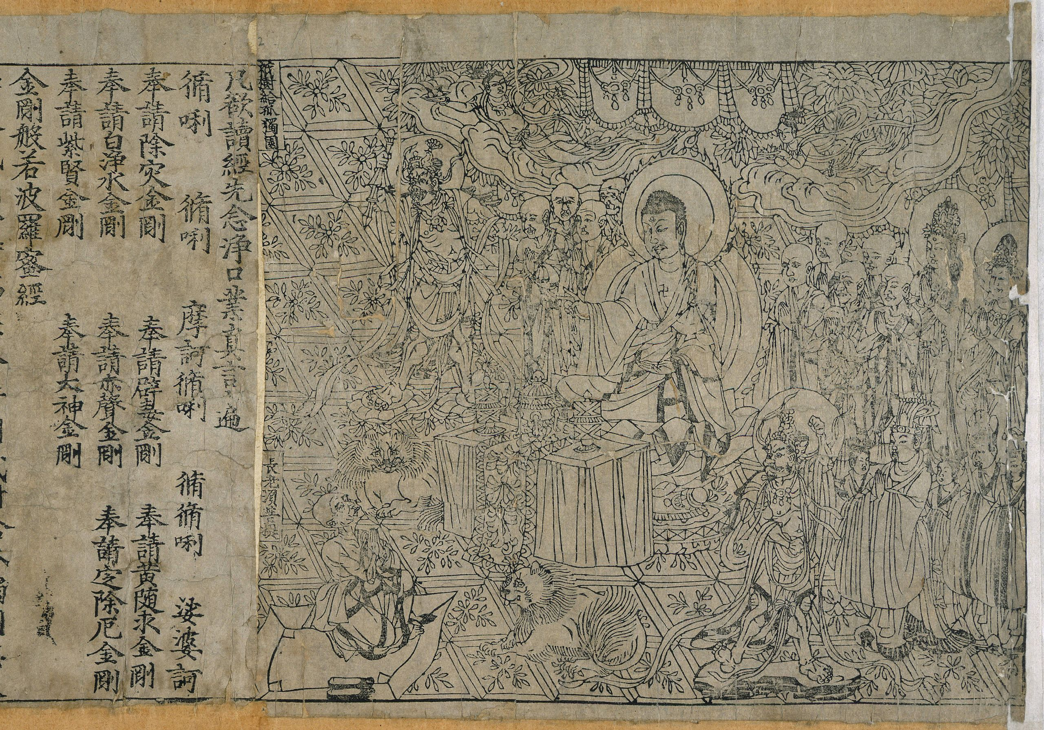

Figure S2. 1: Diamond Sutra ©Wikimedia Commons.



Figure S2. 2: Gutenberg bible Old Testament Epistle of St Jerome, ©Wikimedia Commons

Indeed, human society has entered a new era together with the formation of *mass communication media* such as the printer, radio, television, phone, computer and smartphone. The involvement of machines and mass production marked the beginning of the technological era. When *automation* first became a critical *part of civilization*, social connections gradually shifted from *direct* to *indirect* ways through mechanical means. Instead of face-to-face communication by talking, distance communication through phone, text message, chat, email, or video call were introduced and became an indispensable section of the modern information exchange process. The large scale of social communication increased rapidly. More recently, the invention of the Internet has created simple and ubiquitous connections, unprecedented at any time in history.

Along with the birth and development of mass communication, there has been the continuous upgrowing of the *media industry*, where all the elements related to the communication process have become commodities. The media business has turned the *natural social activity*, the communication process, into *a productive activity* through the process of privatization of means and control of information production, storage, and distribution. Knowledge exchange through writing has been steadily acquired by publishing and search engine businesses, while mail exchange had traditionally been controlled by the postal service industry and, more recently, by email service providers. Social connections have been taken over by social network platforms.

## **Trading Secrets**

In the digital age, the global communication industry is owned by international media conglomerates and new technology empires. Aside from the classic media capitalists such as publishers, newspapers, magazines, radio and television centers contemporary society has witnessed the rise of multinational information technology capitalists. The achievements of digital technology and computer science have supported the current communication industry to become versatile and efficient machines; they are able to simultaneously produce, store and distribute information; likewise, they are able to work with huge volumes of data and perform highly accurate tasks. The most significant among all the new technologies are artificial intelligence, Big data, and the Internet of Things.

Using classic media tactics, contemporary technologies have helped media owners adopt new technical methods for information production, storage and distribution. Previously, the information had been produced exclusively by professional personnel; currently it is often being created by amateurs; and soon, machines will gradually take over this task. Information production previously targeted large social communities; in the present, it tends to be produced for small groups and distributed precisely to the right individual target. While it was necessary to purchase information in the past, that same information has now become a free product. Fundamental changes in *production personnel*, *production goals*, and *financial operating mechanisms* have created a new face for the media industry in the era of artificial intelligence and automation.

*Workforce*

Throughout the 20th century, the majority of information was generated by professional personnel, such as journalists, writers, editors, photographers and designers, working for newspapers, radio, television stations, and publishers. The emergence of digital media contributed to the new personnel management of the media industry. In the 1990s, the rise of the Internet generated strong, utopian expectations about a new freedom paradigm of the online communication that is mainly dominated by individual, amateur information producers and independent publishers.[5] Information consumption was expected to shift from professional to amateur production sources. The weblog is an early example of independent, individual publishing platforms on the WWW and YouTube also witnessed the blooming of independent content producers—the Youtubers—in the early stages of development of the platform.[6], [7] However, soon after that, at the end of the 90s, independent digital media was rapidly subsumed by the appropriation mechanism of capitalism. A new model of labor was introduced into the system: the pseudo-independent producers, who in fact represented the covert professional production staff; for instance, behind the various known reviewers’ websites or YouTube influencers there is often a large team of professional helpers.

By now, Youtubers, Facebook Live-streamers and Tik-Tokers have become actual professions. There is a complex ecosystem of educational, managerial and design services to support these new positions.[8] The artificially constructed ‘individual publisher’ has generated the fake illusions of success in many youngsters of the contemporary digital space. Over the past two decades the desire of many individuals to become successful influencers has contributed to the transformation of cyberspace into a dynamic content creation environment. This dynamism contributes to the smooth and less expensive operation of the digital media industry as well. Instead of investing in content production, the industry is rather focused on providing the storage and distribution infrastructure, while there is a significant increase in the amount of invested work in content production by individuals themselves. With a huge amount of time and effort spent on creating and distributing information on social networks, ordinary users are becoming a free workforce in the service of the information market. In the past, journalists were paid by editorial offices for their writings and photos, while by now the majority of the users–the *digital proletariat*–are investing their work in social media for no revenue at all.

The amateur and unauthenticated information sources from individuals have also made the *fake news phenomenon* more and more popular. Even though fake news has a long history, with the speed of spreading rapidly through the internet space, the phenomenon of fake news has become more threatening, causing more critical consequences and becoming a significant problem of our current society. Fake news can lead to financial market destruction. For example, in 2013, $130 billion in stock value was wiped out in a matter of minutes by an AP tweet about an *explosion* that injured Barack Obama.[9] Fake news has led to mass murders, such as Dylann Roof’s shooting at the Charleston church on June 17, 2015, in the U.S. state of South Carolina.[10] Fake news has also sabotaged many presidential elections around the world; among them, the election of Donald Trump in the U.S 2016 and the Facebook - Cambridge Analytica scandal is the most notable.[11] Producing and circulating fake news can be considered a criminal act. In recent years, penalties for fake news publishing on social media have been enshrined in law by several countries.

Using the pretext of controlling fake news, media owners have increased their dominance and act of censorship information in cyberspace. Fake news is, indeed, published by the authorities themselves, and often spread *legally* for the purposes of political propaganda. In contrast, *real stories* may not be conducive for the purposes of media owners since they are often *constrained* and may sometimes be *banned* from public circulation. Although users are allowed to post personal statements and data on social media, many digital networks and countries have erected barriers of censorship. Information censorship is essentially just moving from offline to online spaces.

Contemporary users are actively creating information within digital networks; nonetheless, their *personal information* is also an important data source in a passive sense. The user information that has been indirectly generated, after being processed through data analysis is secondary information. This information is *a valuable commodity* for trade and exchange on the *data business market*. The need for analyzed information is a foundational demand in all fields of the present society. Traders and manufacturers know the market's demand for their products. The educators need to know the psychology of the learners they manage. The researchers need to know about the impact rates of issues of interest and citations. The medical staffs want to understand the biological body parameters of large social groups, such as heart rate, breathing, blood pressure. The politicians need to know about the specific political trends of the population they will be running for. Promisingly, all of these needs can be served by data analysis results. Through storing personal information, behaviors and actions in digital space, users have contributed to an expansive store of information–the Big Data. Users unconsciously help digital product and service providers amass their personal data, and this becomes the foundation for data owners to conduct analysis and produce statistical information.

Moreover, based on the development of machine learning algorithms, AI content becomes familiar to users today. AI can help correct grammar or spelling and complete documents in different styles. These text completion applications have been adopted widely by service providers such as Google, Apple, Grammarly and other widely used platforms. AI is now applied to text translation with increasingly improved accuracy, such as in the service of Google Translate. AI can also generate informational content for learning, correspondence, business, blog posts, and social media content. Text creation tools appeared very early as *Talk with Transformer* which has created great expectations for the business of automated news creation.*[12]* Up to now, there have been many automatic news creation service providers such as Jasper, Copysmith, Writesonic, Kafkai, Article Forge, Articoolo, Rytr, CopyAI, and Peppertype.[13] In the ever-expanding landscape of digital tools, ChatGPT by OpenAI stands out as a powerful ally in the realm of content generation. Leading media agencies such as Reuters and The Washington Post have also embraced AI tools to enhance their content creation processes, allowing them to produce high-quality work at scale. The Washington Post and Reuters have tested models where *bots* write simple stories, sometimes using artificial intelligence, where the goal is to help the bots improve their writing over time.*[14]* The Washington Post employs its Heliograf *tool*, which generates short stories based on structured data about topics such as election results and sporting events. Forbes is developing an AI assistant for writers called Bertie. Bertie learns from writers' styles, topic choices, and platform publishing preferences.[15]

By far, machine learning can use data and neural networks in a way that mimics the working of a biological brain. Self-study and thinking will bring great strides to the potential of machines to create content. Certainly, the involvement of AI in news creation will accelerate the production processes of the media industry in the coming decades.

*Media design* *workforce*

‘The media are not toys; they should not be in the hands of Mother Goose and Peter Pan executives. They can be entrusted only to new artists because they are art forms.’ *–* Marshall McLuhan.[16]

Canadian communications theorist Marshall McLuhan was the first to use the term *media*in its modern sense related to communication channels. In his book *Counterblast*he considered the media an art form.[17] Elements of signs, symbols, images, and sounds are the essential foundation for constituting media content. Artists, painters, designers, photographers, and filmmakers are the key personnel in the classical media industry. Media design has become a growing career associated with digital media. Consistent with the changes of the media industry in the age of AI and automation, media design gradually moved to a new stage resulting in the shrinking of *professional personnel*, expanding *digital design support tools*, and moving towards *artistic creation by machines*.

In the early 20th century, when mass media appeared, posters were often hand-crafted by famous artists, and the period of hand-designed media lasted until computers became popular in the 1990s. Computer graphic interfaces and specialized design software generated explosive decades of professional media design in the late 20th century. Since the beginning of the 21st century, many semi-automated design tools have been released, supporting untrained media image makers. Users can design logos on automatic services like Wix.com, easily create a text and image layout through Canva.com, design websites through the Elementor tool, and make movies with Adobe spark. Many similar software and design tools are being developed and widely used.



Figure S2. 3: Wix page, ©Wix.com.

**

Figure S2. 4: Canva page © Canva.com.

**

Figure S2. 5: Elementor tool, ©Elementor.

**

Figure S2. 6: Adobe spark, ©Adobe.

Most design support services operate based on accessing a large data stock – a design library. Basically, in the design tool services, the important design elements like composition, the shape of the objects and style are already fixed. With ready-made templates, the services only show users how to replace the necessary design elements to make their own product. Easy to use, these design services became powerful tools for untrained designers. This easy and convenient design process created a society where design elements are everywhere. In the book *Made In China, Designed in California, Criticised in Europe, Amsterdam Design Manifesto,* Mieke Gerritzen and Geert Lovink referred to this phenomenon:

Automation has afforded the affluent citizen of the Western world both more space to shop and more time to exercise their creative chops. Here, designer and consumer merge. The ubiquity of software has meant that suddenly everyone is a de-signer. How hard can it be? The discipline has been democratized from cross-discipline to anti-discipline. But what have we lost, now that craft doesn’t count anymore and design has become a lubricant for any social process imaginable? Design suffers from inflation, becoming absorbed into anything and everything.[18]

Furthermore, with machine learning algorithms, *fully automatic tools for design* could soon become even more popular. Image generation shall become faster. AI image generation software like DALL-E 2 is one impressive example. This AI system has learned the relationship between images and text. DALL-E 2 allowed users to create images from textual descriptions. By explaining an idea, the machine could automatically generate a realistic image. One of the first cases of using image generation AI for design purposes are Karen Chen, a digital artist, who created a magazine cover for Cosmopolitan using DALL-E 2.

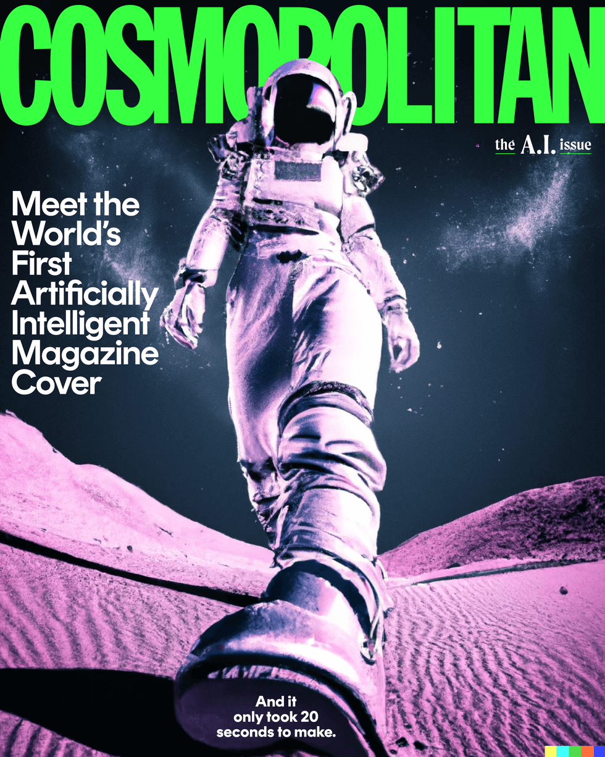

Figure S2. 7: Image Cosmopolitan, ©rockcontent.[19]

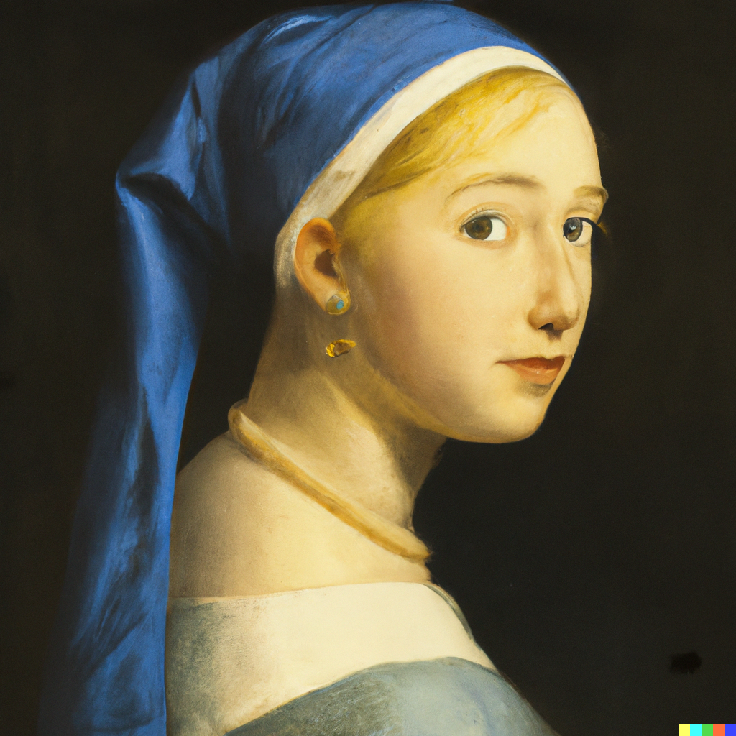 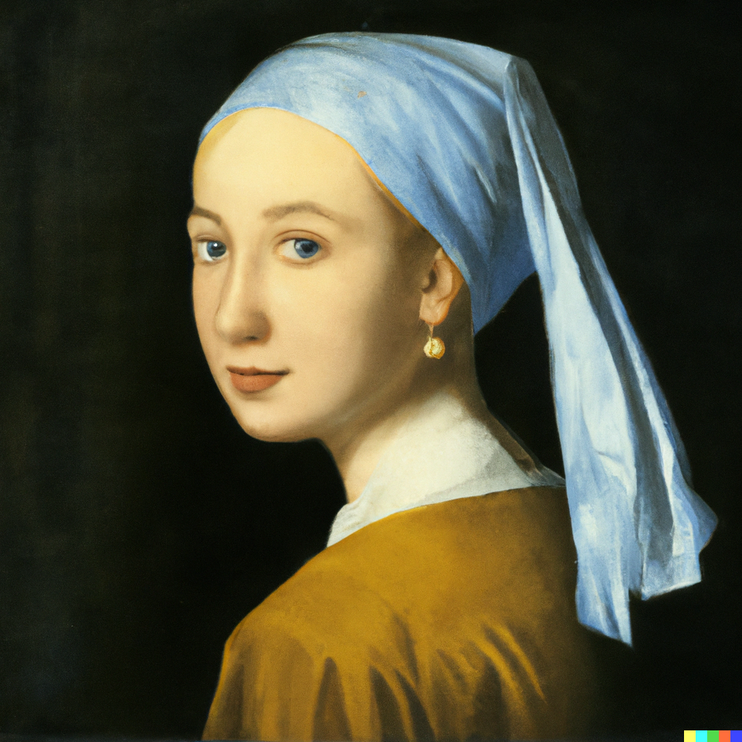

Figure S2. 8: Two variations of Girl with a Pearl Earring generated by DALL-E 2, ©Wikimedia Commons. [20]

The other example is the portrait image generator with SofGAN or TL-GAN. This software has been used to create billions of virtual characters with real human features. These images have been used commonly for virtual accounts on social networks. It is also a source of artificial characters and *virtual influencers* for the advertising market.[21] For example, luxury fashion brand Prada created virtual influencer *Candy* to become the new face of the *Prada Candy* perfume.



Figure S2. 9: Prada Candy perfume ©virtualhumans.org. [22]

The support of new technology has created new entities in post-human society. Users can have many virtual accounts and express their personalities differently from real and virtual life. The flexibility to switch personalities creates multi-personality individuals that are becoming increasingly popular in the new age. In addition, virtual characters that are entirely composed according to the owner's purpose become a new social group – the cyborgs who can mimic or have human characters. One of the characteristics that programmers strive to equip in this machine-human is creativity.

Presently, in the graphic design industry, artificial intelligence machines are able to generate multiple variants after recognizing a pattern. The algorithm is able to extract colors and patterns of a design and then construct other variants within the range of identified colors and patterns. Taking the Nutella Unica design for instance, one testing algorithm was able to shape millions of new Nutella labels from the combinations of its old design (Ahmed, 2019).[23]

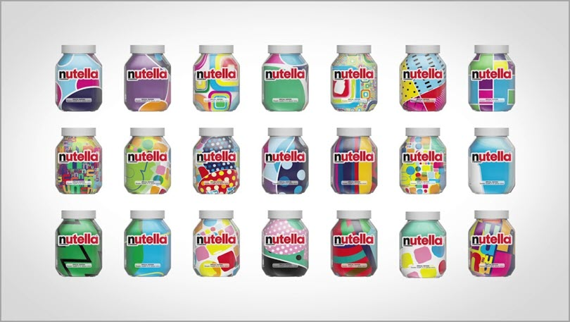

Figure S2. 10: The Nutella Unica design ©jeffbullas.com.

From Kjetil Golid's code art website, we could find five fruity savors from Kômô: Raspberry, Watermelon, Grapefruit, Mango, and Lemon. These are illustrated with artificial designs originating from the Crosshatch-Automata sketch:

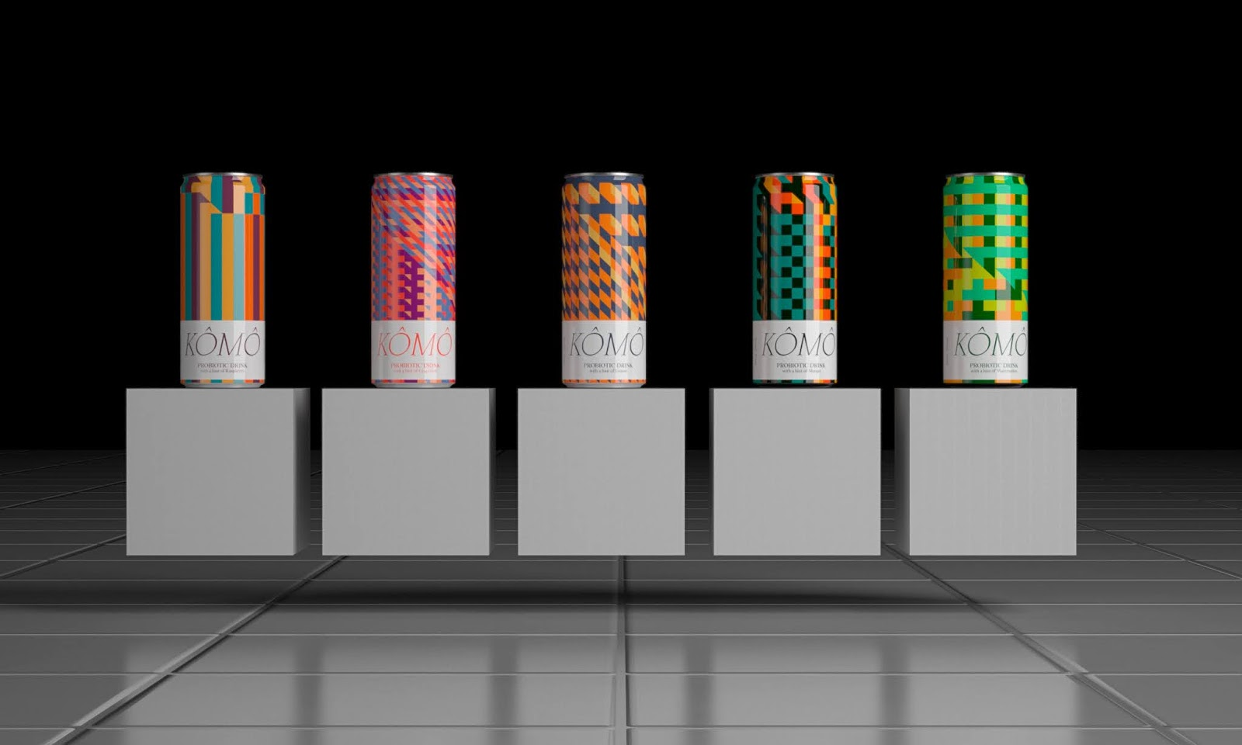

Figure S2. 11: Kômô design ©packagingoftheworld.com.[24]

With visual recognition technology to spot people and objects, AI helps to more quickly and more simply remove the background from a picture. The algorithm analyzes the image, detects the main and secondary objects, and then cuts the picture respectively. The user can refine the cut for better results. Removebg, VistaCreate, Clipping magic and Photoscissors are free AI background removal tools in the existing software market.

**

Figure S2. 12: Vista page, ©create.vista.com.

AI has also brought new strides in improving image quality. Some of the most prominent examples of AI image enhancement tools include Vance AI, Upscaleics, Remini, and Let's Enhance. Several AI-based image enhancement tools are capable of helping to adjust noisy, blurred images to be of high quality, clear and sharp. Using these tools, AI is very proactive in restoring images and improving resolution. AI image enhancement tools are able to replace blurred areas, sharpen them, and save them. In addition, the tool is able to fix poor lighting, contrast, and accuracy in colors in just a few seconds. These tools can also can also resize images without stretching or blurring.[25] AI photo editing applications are now automatically installed on personal mobile devices, profoundly affecting user perception of self-image and the world around them.

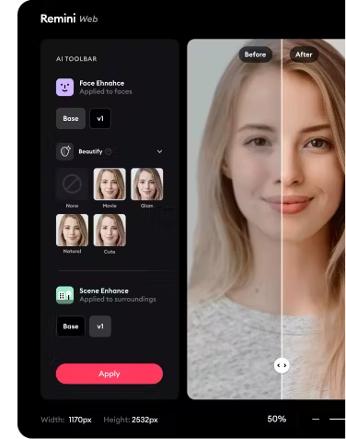

Figure S2. 13: Re Mini apps interface, ©remini.ai.

The *perfected image* of society is a distinct feature of *posthuman living conditions* when machines are deeply involved in constructing the concepts of life.  According to Gerritzen & Lovink, ‘In today’s visual culture, images are more real than real. There is nothing beyond the image’, and indeed nothing seems real unless we post it on social media.[26] The individual existence is dominated by the image of cyber-representation that is obviously distorted fully by devices, machines and software controlled by a small group of people. Therefore, every image around us today is just a designed, subjective reflection.

For a long time, design has been acknowledged as a creative career. When identifying the focus professions of the creative industry, design has always been mentioned first.[27], [28] Creativity is a human essential ability that emerged from the early time of humankind. According to Collins Dictionary: ‘A creative person has the ability to invent and develop original ideas, especially in the arts. Creative activities involve the inventing and making of new kinds of things.’ In the posthuman condition, with the active participation of technology and machines in the creative process, especially in art and design, the standard of new things becomes more controversial.

With the deep intervention of machines in creative activity through design tools, the data library system becomes the foundation for every new product, and the new designs mostly use the existing design elements in the library. Creative modules work by connecting available sets of information. The sets of digital models of artistic styles, color tones, characters, and scenarios generated by information systems become the foundation of contemporary creativity. The less data a library has, the lower the level of design element combination, while the more data a library has, the more diverse the matching will be. Nevertheless, creativity through libraries often does not go beyond what already exists. Thus, the novelty of designing products seems to hang around in the data stock. Somehow, the role of designers might change from creators to curators. The standards of beauty are attributed to certain forms of templates. Mass and similar beauty have become increasingly popular in contemporary media design aesthetics.

In addition, following the personalization trend in marketing, individual needs are identified at the heart of the design process in the present time. *Design thinking* focuses all of its energy on offering solutions to satisfy target customers. The creative process mainly focuses on problem-solving instead of creating new ones. In the words of Gerritzen & Lovink, designing products is ‘invariably the result of a technical solution. Such a model limits reflection to the pragmatic – and paradigmatic – procedural steps: making is reflecting. God forbid that our reflection leaves us empty-handed.’ And that is definitely not what we want from creative activities.[29]

If creativity has been formulated through a reflection process, it obviously loses novelty – the creative core. The creative process may come to an impasse if the involvement of machines is dominant in the design practice. In the main branch of humanist philosophy, human nature is considered autonomous, rational, capable of free will, and unified in itself as the apex of existence. However, in the posthuman context, humans seemingly have been dominated strongly by external factors and digital devices. All the acts of contemporary humans, from awareness to actions are all manipulated. Even the creativity of design navigates according to an existing scenario. Overall, we now live in a society where everything is related to design, and our society only changes when design results are refreshing. In contrast, when the creative process is simply the act of combining what is available in a given library and creativity is coordinated by a small group of programmers, the development of society becomes threatened.

As with other professions in the traditional media industry, the media design field has witnessed fundamental changes in the job market. While the number of professional media designers has diminished along with growth in the number of amateur media designers, the proliferation of automated design tools will increase.

Predictively, expert designers will be playing an important role in the near future until technology takes further steps and overcomes its current limitations. Simultaneously, unprofessional designers as a group are likely to diminish and even disappear over time. Analogue design methods that do not involve digitization will have the opportunity to survive and enter the same high-priced niche as the current antique market. *New* design jobs will appear with *new* platforms with *new* technology applications. In the next 10 years, the 3D design and virtual reality will have a larger market share than they currently have. Video design will prevail over still image designs. Post-human societies will witness boundless intermingling in the design work of humans and machines. In order to make the parallel existence of humans and machines add goodness to life, the acts of analysis, criticism and revolution in the present are very important and decisive.

*Information**production**and**distribution**objectives*

In the early days of the media industry, communication products created based on the favors and ideas of the manufacturers - publishers. When the information was hard to find, every piece of news became extremely valuable. In my childhood, I still remember that I used to cut out beautiful illustrations or photos, good stories, news pieces from the newspaper(s), and store them. The children of my generation in Vietnam still gather at exactly 6:45 p.m every day to watch only 15 minutes of cartoons on the national public television program. Having access to the press, news and entertainment from the late 20th century is very rare and privileged in my region of Vietnam. Twentieth century information producers often paid less attention to the audience.

The production goal of 20th century media aimed at the masses and large community groups. The social groups defined by gender (male or female), by age (children, adolescents, middle-aged and elderly), and by race (people of color, whites, people of Asian descent) became more obvious in media strategies in the late 20th century. The early stages of the public relations industry have mostly targeted changing the mass perception. The lack of and thirst for information made any piece of it extremely valuable; therefore, they have an enormous impact on society. In addition, in South-East Asia in the period preceding the 1970s, there were sharp characteristics of a less divided society, collectivism strongly dominated many communities after some major wars, and society navigation in large groups seemed quite convenient. Mass targeting was the most obvious goal of the 20th-century media industry.

Entering the information overload era, media becomes superfluous, supply is over demand, and the economic value of news decreases remarkedly. Societies of the late 20th and early 21st centuries had experienced the rise of a noticeable social divide, with individualism spreading from developed to developing countries. From that point on, the media industry had to take a different turn. Media conglomerates began to focus more closely on individual needs. The characteristics of each reader have been scrutinized because media owners recognize that, in the new age, information only becomes valuable if it fits the needs of each customer. Properly capturing individual needs becomes the central paradigm of producing and distributing information in contemporary society.

With the assistance of AI, personal data is easily recorded, analyzed, and made available through digital platforms. Demand characteristics of each user becomes an available and accessible data. Machine learning algorithms can optimize the production of information and send the right information to the right people. For example, the machine is able to identify a user who is a woman, has a MBA degree, works in accounting, has a stable job at a bank, has frequent feelings of sadness, and longs for weight loss. Her specific personal data was recorded through her various activities on digital services that the woman left behind in cyberspace. The information about this woman will be coded as a set of keywords such as woman, high education, accountant, bank, sad and weight. This code may then be stored on the platform and used to sort relevant marketing information over time. The targeted information will normally appear on the personal digital interface such as mobile apps, web searches or social networks. This automatically generated information can be extremely diverse, such as invitations to join program, advertisements on banners web, video commercials on YouTube and compatible search results on search engines.

Meanwhile, media have identified personalizing as the essential goal in production, storage and distribution of information in order to successfully compete in the age of information overload and to take advantage of AI technology.

*Financial**operating**mechanism*

In the last century, subsidies from political organizations and governments and the direct sales of news have been the main financial sources of the media industry. If readers cared to find single, independent sources of information to replace the politically altered propaganda, they had to pay. In the late 19th century, the main revenue of the media industry depended on the sales of books, newspapers, and magazines. Following that, the forms of commercializing information through radio were popular in the first decades of the 20th century, when customers could call or ask the switchboard operator on the telephone for information such as: weather, gold price or lottery results. In the middle 20th century, customers could buy specialized TV channels such as news, films, sports and shows by subscribing to various TV stations.

Presently, in the digital media world, the digital media world provides most information free of cost. Internet users are able to freely search and use a huge and varied amount of information available to them in cyberspace. With information so readily available on line, with free access a widespread phenomenon, the economic and political value of traditional media has decreased significantly. Consequently, political communication is less effective than previously, with lower revenues flowing to classical media outlets. Users gradually switch to finding and using free information instead of paid information. In this new financial environment, many newspapers and radio stations have difficulties maintaining their operations. The shrinking of traditional media owners, such as books, newspapers, radio, and TV, has spurred the expansion of digital media owners. At the beginning of the 21st century, the media industry began to gradually transition to a new financial operating mechanism.

Even though media income from direct sales and subsidies has shrunk, and most information is distributed free of charge, digital media owners remain the wealthiest businesses in the world.[30] If most of the information is free, from where do their profits come? In fact, media empires still make their fortune from information, but not from the media delivered to customers, but from the *customers' information* they systematically and, at times, *secretly collect*. Changing the direction of information flow has become the strategy for making today's information technology corporations more profitable. Harvard Professor Shoshanna Zubov, the author of the book *The Age of Surveillance Capitalism* considered that we had come into this new world thinking that we were social media users. She also wondered whether we use the social media, or the other way around: ‘We mistakenly believed that we were searching Google and had no idea that Google was searching us.’[31]

Media revenues gradually have gradually shifted toward selling user data, advertisements, or rights-to-use and recurring subscriptions. User information is the raw material that is used to create valuable statistical information for many industries. The groundwork for targeted advertising, especially, is found in the captured individual characteristics of harvested user information. Advertising optimized by machine learning algorithms has reaped enormous profits for digital media companies. User information has also been employed in the operation of licensing services or recurring subscriptions system. For example, the entertainment channels such as Netflix will optimize the topic scope through user data, which allow them to send the most suitable and attractive products to the customer. This is also the way to keep users within certain media service packages in the long term, while effectively increasing the revenue of digital media corporations. Personalizing in the production and distribution of information is a prominent feature and the new monetization method of the contemporary media industry.

*Old tricks, new forms*

In the 1920s, Edward Bernays, Sigmund Freud’s American nephew, conceived of the public relations profession and was the first person to take Freud’s ideas and use them to manipulate the masses. Bernays introduced American corporations to how they could make people want things they *didn’t need* by systematically linking *mass-produced goods* to their *unconscious desires*.[32]Bernays’ tactics of influencing society through psychological effects still have a dominant value today.

In the documentary series *The Century of the Self*, Adam Curtis pointed out that Bernays was one of the coaches for modern media.*[33]* He was famous for his techniques of mass-consumer persuasion, using different tactics, from celebrity endorsement and outrageous public relations stunts to eroticize the motorcar. One of the most memorable demonstrations of Bernays' communication strategies was breaking the taboo on women smoking by persuading them that cigarettes were a symbol of independence and freedom. He proved that this was more than just *a way of selling* consumer goods, rather a new political idea of *how to control* the masses. Communication has the ability to encourage the need to satisfy the inner irrational desires that Sigmund Freud had identified. Through this satisfaction, people could be made happy and thus docile. That is how the consuming self was established, a concept which has come to control today's world.

Basically, the modern media conspiracy is grounded in this specific application of Freud's psychoanalytical methods. By proposing a *technique* to probe the *unconscious mind*, Freud provided useful tools for discovering the secret desires of the masses. His work served as the precursor to the world with many political spin-doctors, marketing moguls, and a society that believes in the pursuit of satisfaction and happiness as humankind foremost goal.

Recognizing the importance of the unconscious mind, media owners from the 20th century to the present have invested considerable effort and resources in social psychology research. The contemporary world has revealed a change: rather than manual survey techniques with paper and pen, with multiple choice questionnaires or face-to-face interviews, the digital survey technique, using machines on a large scale, became the main research method. With lower cost, faster speed, and more up-to-date technology, an automated process of probing society's unconscious mind with automatic tools is more effective in this new age.

While media systems of commercial companies try to maintain an apparatus that produces the demand for happiness and satisfaction, the media systems of different governments attempt to influence the subconscious mind of individuals with endless anxieties and fears. It has become possible for commercial and political media to actually generate conspiracy theories. The fake news and propaganda that create fears from events that may never happen generates commercial and political advantages for media owners. *In Media Control: the Spectacular Achievements of Propaganda*, Noam Chomsky once wrote ‘You've got to keep them pretty scared, because unless they're properly scared and frightened of all kinds of devils that are going destroy them from outside or inside or somewhere, they may start to think, which is very dangerous, because they're not competent to think.’[34]

As a result of a model scenario played out in many countries today, the media are being used by the political class to create constructed images of the ‘evil’ that threatens national interests; at the same time, political channels create the image of heroes as well – namely, the politician who protects the nation from the illusory enemy. Most of these villains usually belong to other races, foreigners, and immigrants; their image is associated with actions of taking jobs, occupying land, destroying culture and mixing noble bloodlines. These political plays contribute to the selfish nationalism that has sprung up in many parts of the world. Media conspiracies associated with extreme nationalism are one of the many media tactics that political parties have used over the centuries and are still popular in digital world today.

By distancing the images of the world from reality and implementing the lie and threat scenarios, many media companies attempt to dominate and control societies in the name of democracy and individual freedom. The virtual space has pushed these scenarios further and further away from reality, as Noam Chomsky formulates: ‘The picture of the world that's presented to the public has only the remotest relation to reality. The truth of the matter is buried under edifice after edifice of lies upon lies. It's all been a marvelous success from the point of view in deterring the threat of democracy, achieved under conditions of freedom, which is extremely interesting.’[35]

As in the last century, the media have created countless images representing all issues in the most beneficial way to sponsors – business owners, corporations, organizations, and governments. The concept of beauty is constantly sharpened and changed according to social media campaigns. The standard lifestyle has been shaped through online advertising campaigns. Mainstream political support has been guided through the waves of news spread on social media networks. Inner irrational desires and fears of individuals have been encoded in the complex system of signs, symbols, signals, and semiotic conventions through cyberspace. The remarks of Guy Debord in his 20th century book, *The Society of the Spectacle* remain valid today; societies have been defeated by the current production conditions when life has been presented as an immense accumulation of spectacles. Any direct lived experience has receded into representation through the impact of the content of: articles; magazines; books; images; sound; entertainment forms such as games, movies, and music; research information production; survey data; and advertising. Perception of modern human life is attacked in full force by *artificial spectacles*.

Entering the hyper-fake online society, the skills required of 21st century people are to question what is named the truth, what is the necessary distance to be able to re-evaluate the representative images, and how to control emotions in front of spectacular and skillful fake performances. Max Weber noted: ‘It is not true that good can follow only from good and evil only from evil, but that often the opposite is true. Anyone who fails to see this is, indeed, a political infant.’[36] Comparing and contrasting information and critical thinking are much more important in the digital media age.

Media owners have positioned people into naive and silly spectators of different political plays, setting them up for unfounded panic and erroneous beliefs. The most obvious difference we see in the current media technological change is that the intensity of influence increases, the means of the impact are enriched, and the personalization is higher. The new situation contributes to the creation of deep beliefs and fears in society.

In the age of AI and automation, we are witnessing changes in production personnel, production objectives, modes of production, sales and delivery of information, and ways of generating revenue for the media industry. The vast amount of information is mainly consumed online. The domination techniques of the new media industry are mostly relying on machines and efficient algorithms. However, the nature of *social manipulation* through the media *has not changed* considerably since the dawn of the last century.

**References**

Ahmed, Umar. ‘The Top 6 Ways Artificial Intelligence Will Affect Design in the Future.’ *Jeff Bullas*. Last modified 2019. https://www.jeffbullas.com/artificial-intelligence-design/

Chomsky, Noam. *Media Control: The Spectacular Achievements of Propaganda*. Seven Stories Press, 2002.

Cobley, Paul. ‘Communication: Definitions and Concepts.’ In *The International Encyclopedia of Communication*, edited by Wolfgang Donsbach, 71. Chichester, UK: John Wiley & Sons, Ltd, 2008.

Gerritzen, Mieke, and Geert Lovink. *Made In China, Designed in California, Criticised in Europe*. Institute of Network Cultures, 2019.

Hart, Michael. ‘This AI Text Generator Is Terrifyingly Human.’ *Nerdist*, 2019.

Haseeb, Azhar. *How To Become A Successful Youtuber*, the Udemy online course, 2021.

Hesmondhalgh, David. *The Cultural Industries*. SAGE, 2002.

Hiort, A. ‘Prada Creates Virtual Muse Named Candy.’ *Virtual Humans*, 2021. https://www.virtualhumans.org/article/prada-creates-first-virtual-muse-candy

Howkins, John. *The Creative Economy: How People Make Money From Ideas*. Penguin, 2001.

Doyle, Krista. ‘9 Best AI Content Generators for Every Kind of Content in 2023.’ *Jasper*, 2022.

Kapoza, K. ‘Can 'Fake News' Impact the Stock Market?’ *Forbes*, 2017.

Lovink, Geert. *Dynamics of critical internet culture (1994-2001).* Vol. 1. Theory on Demand, Institute of Network Cultures, Amsterdam, 2009.

McLuhan, Marshall, and Harley Parker. *Counterblast*. New York: Harcourt, Brace & World, 1969.

*The Century Of The Self Part I: The Happiness Machines* (Adam Curtis, 2002) Documentary Series, BBC Two, 17 March 2002. https://www.youtube.com/watch?v=DnPmg0R1M04

Weber, Max. *From Max Weber: Essays in Sociology*. Routledge, 2013.

Wilson, Peter Lamborn. *Pirate Utopias: Moorish Corsairs & European Renegadoes*. Autonomedia, 2003.

Wittmann, Alexander. ‘Chasing Profitability in a Changing Media Landscape.’ *Oracle Net Suite*, 2022.

1. Paul Cobley, ‘Communication: Definitions and Concepts.’ In *The International Encyclopedia of Communication*, edited by Wolfgang Donsbach, 71. Chichester, UK: John Wiley & Sons, Ltd, 2008.
2. **communication medium** such as human body, human voice, paper, pen, engraving, printer, radio, TV, phone, computers, smartphones, wearables, VR […]
3. Wikipedia contributors, ‘Diamond Sutra’, 10 October 2022. https://en.wikipedia.org/wiki/Diamond_Sutra#/media/File:Jingangjing.jpg.
4. Wikipedia contributors, ‘Gutenberg Bible’, 10 October 2022. https://en.wikipedia.org/wiki/Gutenberg_Bible.
5. Peter Lamborn Wilson, *Pirate Utopias: Moorish Corsairs & European Renegadoes*, Autonomedia, 2003.
6. Geert Lovink, *Dynamics of critical internet culture (1994-2001),* Vol. 1. Theory on Demand, Institute of Network Cultures, 2009.
7. Rebecca Blood, ‘Weblog History,’ archived May 30, 2015, Web Archive, 10 October 2022, https://web.archive.org/web/20150530144950/http://www.rebeccablood.net/essays/weblog_history.html.
8. Azhar Haseeb, ‘How To Become A Successful Youtuber’, *Udemy online course*, 25 November 2021.
9. Kenneth Rapoza, ‘Can 'Fake News' Impact the Stock Market?’ *Forbes*, 2017,

   https://www.forbes.com/sites/kenrapoza/2017/02/26/can-fake-news-impact-the-stock-market/?sh=56dbf952fac0.
10. Wikipedia contributors, ‘Dylann Roof’, 10 September 2022, https://en.wikipedia.org/wiki/Dylann_Roof.
11. Wikipedia contributors, ‘Facebook–Cambridge Analytica data scandal’, 10 September 2022, https://en.wikipedia.org/wiki/Facebook%E2%80%93Cambridge_Analytica_data_scandal.
12. Michael Hart, ‘This AI Text Generator Is Terrifyingly Human.’ *Nerdist*, 2019.

    https://nerdist.com/article/ai-text-generator-human.
13. Krista Doyle, ‘9 Best AI Content Generators for Every Kind of Content in 2023.’ *Jasper*, 2022. https://www.jasper.ai/blog/ai-content-generator.
14. Bot is a computer program that runs [automated](https://www.oxfordlearnersdictionaries.com/definition/english/automate) tasks over the internet.

    Oxford Learners Dictionaries, ‘Bot’, *oxfordlearnersdictionaries.com,* 15 May 2021.
15. Alexander Wittmann, ‘Chasing Profitability in a Changing Media Landscape.’ *Oracle Net Suite*, 2022. https://www.netsuite.com/portal/resource/articles/financial-management/media-revenue-models.shtml.
16. Marshall McLuhan and Harley Parker, *Counterblast*. New York: Harcourt, Brace & World, 1969.
17. Marshall McLuhan and Harley Parker, *Counterblast*. New York: Harcourt, Brace & World, 1969.
18. Mieke Gerritzen and Geert Lovink, *Made In China, Designed in California, Criticised in Europe*, Institute of Network Cultures, 2019.
19. Rock Content, ‘6 Ways Artificial Intelligence Will Affect Design in the Years to Come.’ *rockcontent.com*, 30 March 2022. https://rockcontent.com/blog/artificial-intelligence-design.
20. Wikipedia contributors, ‘DALL-E’, 10 August 2022, https://en.wikipedia.org/wiki/DALL-E.
21. Virtual influencers are someone (or something) with the power to affect the buying habits or quantifiable actions of others by uploading some form of original—often sponsored—content to social media platforms like Instagram, YouTube, Snapchat or other online channels.

    Wikipedia contributors, ‘Influencer marketing’, 10 August 2022. https://en.wikipedia.org/wiki/Influencer_marketing.
22. Astrid Hiort, ‘Prada Creates Virtual Muse Named Candy.’ *Virtual Humans*, 2021. https://www.virtualhumans.org/article/prada-creates-first-virtual-muse-candy.
23. Umar Ahmed, ‘The Top 6 Ways Artificial Intelligence Will Affect Design in the Future.’ *Jeff Bullas*. Last modified 2019. https://www.jeffbullas.com/artificial-intelligence-design.
24. Studio Blackthorns, ‘Kômô Probiotic Packaging Made with AI Design.’ *Packaging of the World*, 2021. https://packagingoftheworld.com/2021/01/komo-probiotic-packaging-made-with-ai.html.
25. Rock Content, ‘6 Ways Artificial Intelligence Will Affect Design in the Years to Come.’ *rockcontent.com*, 30 March 2022. https://rockcontent.com/blog/artificial-intelligence-design.
26. Mieke Gerritzen and Geert Lovink, *Made In China, Designed in California, Criticised in Europe,* Institute of Network Cultures, 2019.
27. John Howkins, *The Creative Economy: How People Make Money from Ideas*, Penguin, 2001.
28. David Hesmondhalgh, *The Cultural Industries*, SAGE, 2002.
29. Mieke Gerritzen and Geert Lovink, *Made in China, Designed in California, Criticised in Europe,* Institute of Network Cultures, 2019.
30. Wikipedia contributors, ‘List of largest companies by revenue’, 12 January 2022, https://en.wikipedia.org/wiki/List_of_largest_companies_by_revenue.
31. *In the Age of AI* (dir. Fanning, D. & Docherty, N. 2019), Documentary film, Frontline, at:

    https://www.youtube.com/watch?v=5dZ_lvDgevk.
32. *The Century Of The Self Part I: The Happiness Machines* (dir. Adam Curtis, 2002) Documentary Series, BBC Two, 17 March 2002. https://www.youtube.com/watch?v=DnPmg0R1M04.
33. *The Century Of The Self Part I: The Happiness Machines* (dir. Adam Curtis, 2002) Documentary Series, BBC Two, 17 March 2002.
34. Noam Chomsky, *Media Control: The Spectacular Achievements of Propaganda*, Seven Stories Press, 2002.
35. Noam Chomsky, *Media Control: The Spectacular Achievements of Propaganda*. Seven Stories Press, 2002.
36. Weber, Max. *From Max Weber: Essays in Sociology*. Routledge, 2013.